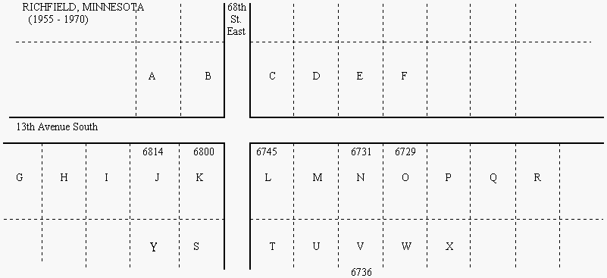
A Olson (Gordon + Bea (remarried), Gloria, Marsha [m])
B Winden (Warren Sr[d], Warren [m murdered], Georgie[m], John)
C a) Seyer ( + , Jeanne[div] and two sisters)
b) Couple
D a) Hughes ( + , Danny)
b) Barnette ( + , Janice and 2 very young blonde girls)
c) Duffy (Frank + ?, Diane, Julie, Dan)
d) Mexican family
E a) Valenders ( + ,2 older girls)
b) Resler (Gene + Sheri)
F Knoss (parents deceased, Donny[m], Richard[m])
G a) Sandquist (Art[d] + Pauline[d], Rene[m], Cindy[m], Denise[m], Jeff[div])
b) Melissa S
H Baker (Harold[d] + Harriet[d], Sharon[wid/daught], Debbie[div, 4 girls])
I Gartland (Howard [d]+ Venita [d], Judy [widow])
J Daniels (Kincy G[d] + Marge, Kincy A, Terri[div/m/son], Lori[son])
K a) Lundgren (Dale [d] + Rita, Paul, Nancy)
b) Roger
L a)Roed (Harold + Mary[d], Signe[div,m], Karen[m], Joan[m], Cheri[m])
b)
M a) Tanner (Minister + , Jim, Bob & boy)
b) Fair (Lester+Marie, Darlene, Lester (Jerry), Daneeta, Danny moved 30 Aug 1963)
c) Johnson ( + , Bonnie, Barnetta, Brian)
d) Swanson (Roy + Bobbi[d], Scott, Kent, Lynn)
N a) Malecek (John[div/d] + Eva[div,m,d], John[m], Angie[div/m], Chris[m])
b) Sodeberg (Daryl + Rose, Jeff, Marlys)
c) bachelor
O Breth (Bill[d] + Evelyn[re-m Art Munson,d], Sandra[m], Billy[m,div,d]
Janice[m], Patrice[m] Jolene[m], Denise [m, div])
P Fromer (old couple with 2 hunting dogs [Queenie])
Q Williams ( + , Craig, Steve)
R Overdahl (Roy[d] + [d], Linda[m])
S Piram ( + , Bobby[m], Carol[m], Chuck[m], Gary[m], Dorothy and Diane[twins])
T ? (Art[d]+ )
U a) Meyer
b) Forkenbrock ( + , Beth)
c) Mexican family
V a) Palmer ( + , Kathy, Bobby)
b) Newstrom (Gene[d] + Grayce[d], Steve[div,m], Karen/Roger[m], Julie[m])
c)
W Henkel (Ernie[d] + Loraine[d], Lyn[div])
X a) Hines ([d] + , Bradley(aka "Pots"), Milo[d])
b) single woman
Y Shevland (“Grandma”)
[m] = married [d] = deceased [div] = divorced
bold = current occupant
Updated 2021 by John Malecek

For more go to http://www.malecek.com/otd/mem/neighbor.html

